Name: Rasha Mansour

ID:1210773

**2.6 Post Lab**

1.Design 8-bit BCD adder.

(8-bit BCD=two 4-bit BCD)

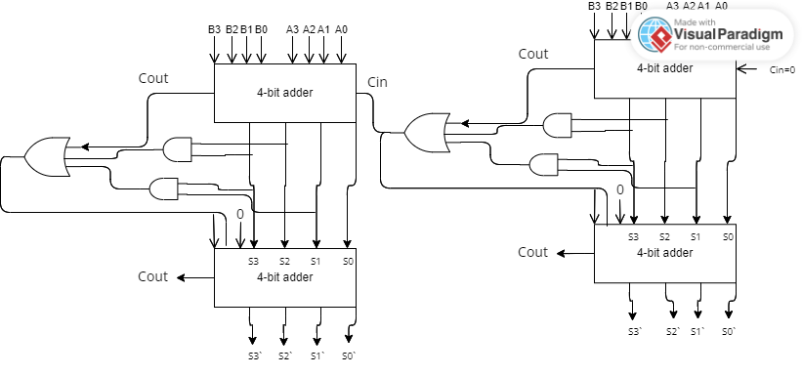

2.Design 8-bit comparator using 2 of 4-bit comparator.

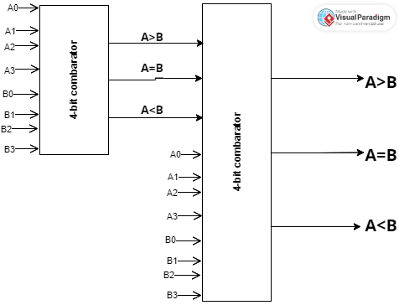

And here another answer:

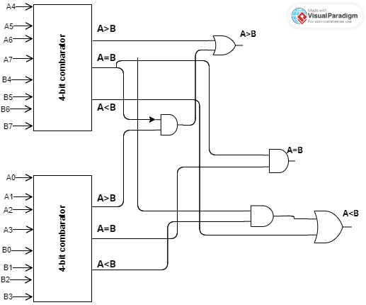

3.A 4-inputs, 3-outputs circuit that compares 2-bit unsigned numbers and outputs a ‘1’ on one

of three output lines according to whether the first number is greater than, equal to, or less

than the other number. You can only use two 4×1 multiplexer.

